**Case 5-Asia-China-Hongshan-Sheep sculpture-ca 2500 BCE**

**Hongshan Culture Expands Trade and Exchange into Mongolia**

Sheep sculptures were added by artisans to their porcine repertoire as Hongshan trade and exchange with Mongolian sheep herders developed. This suggests increasing cultural complexity and stability, although the degree of complexity and Hongshan connections to other emergent Neolithic cultures in Mongolia and Central Asia are still under debate (Guo 1985).



 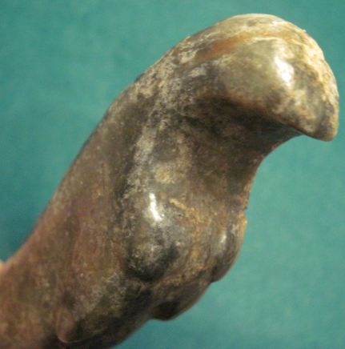   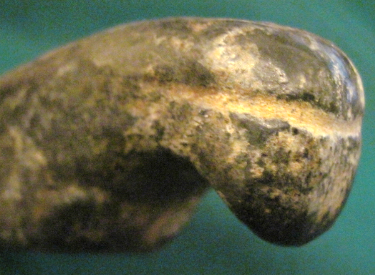

Rare mid-late Hongshan culture sheep sculpture, ca 2500 BCE, Atlantika Collection